Karniol Małecki i Wspólnicy Sp. k.

CIS LOCAL COUNCEL FORUM IN BAKU

20-22 JUNE 2007

OIL & GAS
Poland the business player
on the oil and gas Euro – Asiatic Market

Adw. Robert Małecki
Partner of Karniol Małecki i Wspólnicy Sp. k.

KARNIOL MAŁECKI I WSPÓLNICY Sp. k.
00-236 WARSZAWA, UL. ŚWIĘTOJERSKA 5/7
TEL. (48 22) 828 14 60, FAX (48 22) 827 04 63
e-mail:skm@skm.pl, www.skm.pl
Member of European Group of Law Firms
Avenue de Tervuren 270, 1150 Brussels, Belgium
TEL: +32 2 234 6710, FAX: +32 2 280 4779
e-mail: info@Nomos-Alliance.com, www.nomos-alliance.com

Warsaw, June 2007

Contents

I. The structure of the Polish gas market | 3
II. The structure of the Polish petroleum market | 6
- The diversification of gas and petroleum supplies and the security of the country’s power supplies | 8
- Business activity in the area of the transmission, distribution and trade of fuel gas and liquid fuels in Poland | 11
- The directions of the government’s policy regarding the Polish gas and petroleum industry | 13

I. The structure of the Polish gas market

The Polish market is characterised by the dominant position of the public limited company Polskie Górnictwo Naftowe i Gazownictwo SA (PGNiG). The Public Treasury now holds a majority of shares in the company, namely 84.75%.

1.) The transport of natural gas to users is made by transmission and distribution gas pipelines. Transmission gas pipelines are about 14,000 km long.

The distribution networks are about 100,000 km long. They supply gas to 6.8 million homes.
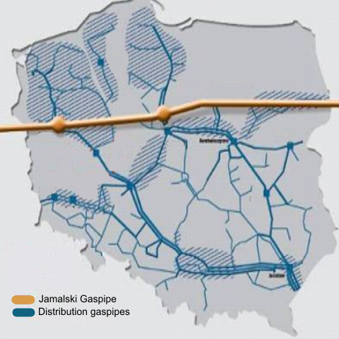

(Map above - Jamal gas pipeline with PGNiG distribution gas pipelines)

2.) The yearly consumption of natural gas in Poland in 2006 amounted to 13.9 billions of m³. The domestic extraction of gas in 2006 provided approximately 30% of Poland’s annual need for natural gas. With such a low level of domestic extraction, most of the gas used in Poland is imported.

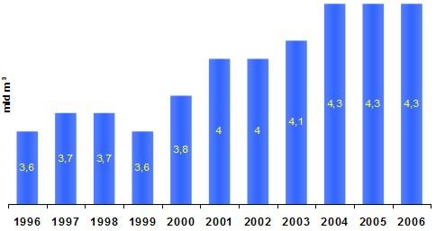
(Table above – Level of extraction of gas in Poland)

3.) The structure of supply of natural gas to Poland in 2006 was the following:

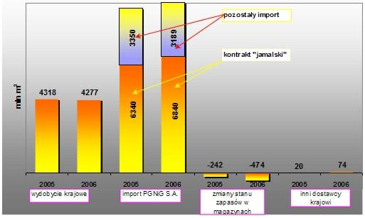

(Table above – Structure of supply of natural gas to Poland in 2006)

a) Jamal contract (natural gas imported from Russia through the Jamal gas pipeline running from the Jamal peninsula) applies until 2022 inclusive. If the parties do not withdraw from the contract by the end of 2019, the contract will be automatically prolonged for the next 5 years – 6.84 billion m³

Amount of gas to be purchased under the Jamal contract in various years:
years | Amount of gas under the contract in millions of m³per year
2006 - 2007 | 7,100 p.a.
2008 - 2009 | 7,300 p.a.
2010 - 2014 | 8,000 p.a.
2015 - 2022 | 9,000 p.a.

b) Contract with RUE (RoksUkrEnergo) for the import from Central Asia countries –– 2.34 billions of m³

c) spot supplies (also called occasional supplies) from Germany – 0.47 billions of m³

d) spot supplies from Norway – 0.36 billions of m³

Additional information

The Baltic gas pipeline is a Russia and Germany initiative. It will run on the bottom of the Baltic Sea and directly connect Russia and Germany. The target flow capacity of two pipes of the pipeline should amount to 55 billion m³ of gas per year. The pipeline will be 1,200 km long. The project for such a gas pipeline gives rise to many political controversies.

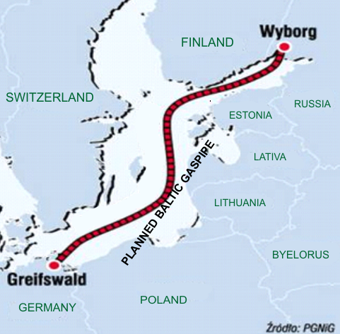

II. The structure of the Polish petroleum market

Poland does not have many petroleum layers and therefore most of its petroleum is imported. The yearly amount of petroleum extracted in Poland does not exceed 1 million tons.

The main supplier of petroleum to Poland is Russia. Petroleum is supplied by the “Friendship” pipeline being an important link in the Central European system of pipelines. Besides Poland, it also supplies petroleum to other European countries such as: Belarus, Ukraine, Lithuania, Latvia, Hungary, Slovakia, Czech Republic and Germany.

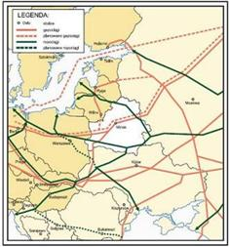

In 2005, the import of petroleum from Russia amounted to about 17.5 million tons, while the import from other countries, such as: Kazakhstan, Ukraine, Norway, and Great Britain, reached a total of approximately 446,000 tons.

The sources of Polish import of petroleum to Poland

IMPORT
Lp. | Country | Amount | Value
 |  | In thousands of tons | In thousands of PLN
 | World (in total) | 17 641,27 | 19 963 760
1 | Russia | 17 199,36 | 19 418 651
2 | Kazakhstan | 142,96 | 174 256
3 | Norway | 130,23 | 164 360
4 | Great Britain | 87,14 | 114 228
5 | Ukraine | 63,85 | 68 738
6 | Czech Republic | 17,74 | 23 509

In Poland, the production of liquid fuels is dominated by Polski Koncern Naftowy ORLEN SA in which the Public Treasury is the largest shareholder and holds 27.5% of shares, and Grupa Lotos SA in which the Public Treasury holds the majority of shares, namely 58%. Those companies have a total of 7 refineries in Poland: in Płock, Jedlicze and Trzebini (for PKN Orlen) and in Gdańsk, Czechowice, Gorlice and Jaśle (for the LOTOS group).

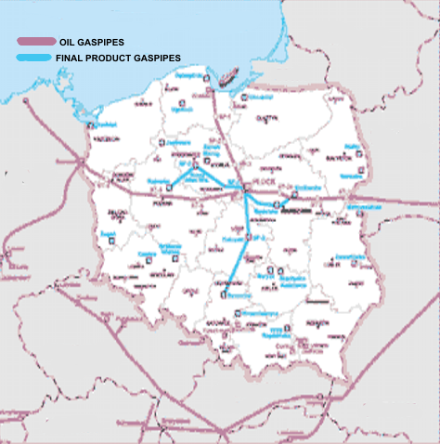

(Map above – petroleum pipelines and final product pipelines)

III. The diversification of gas and petroleum supplies and the security of those supplies for Poland.

The diversification of gas and petroleum supplies is an essential challenge for Poland in securing the country’s power supplies.

A.) Planned ventures and investments aimed at diversifying the supplies of gas:

- Construction of a coastal terminal adapted for the reception of liquefied natural gas (Świnoujście).

- Construction of the Norwegian Gas Pipeline to run from the Northern Sea across the Baltic Sea. The gas being transported this way would also be sent to Sweden and Norway.

- Construction of the Sarmate pipeline for the transport of gas from Iran across Ukraine.

- Construction of the Nabucco pipeline to transport gas from Iran and Azerbaijan through Turkey, Bulgaria, Romania and Hungary down to Austria. Poland would be allocated 15% of the total imported.

The following maps show the former and current proposals for the diversification of gas supplies to Poland:

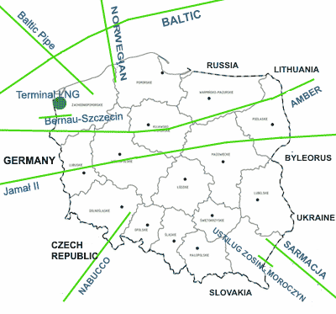
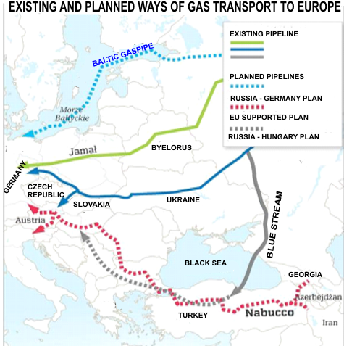

B.) Planned ventures and investments aimed at diversifying petroleum supplies

The initiating and supporting of actions of EU bodies for the construction of an international petroleum transmission infrastructure, such as the extension of the Odessa- Brody pipeline to Płock shown on the map below. If such project is completed, Poland would not only become an end user of petroleum from Central Asia but it would also play an important role in the transit of that raw material.

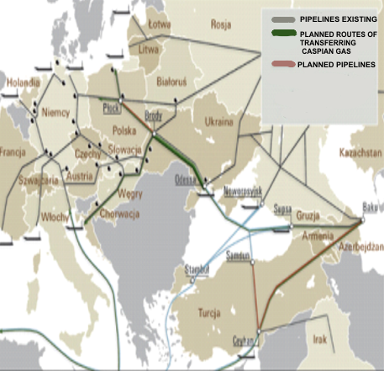

It should be mentioned that Poland is the initiator of the proposed entry into the new EU Constitution Treaty of a clause on power solidarity. Such initiative would create the obligation of providing assistance to any EU country which has been cut off from the supply of power raw materials.

IV. Business activity in the area of transmission, distribution and trade of fuel gas and liquid fuels in Poland

Those issues are regulated by the following Acts:

- Act on Freedom of Business Activity of 2 July 2004

- Energy Law Act of 10 April 1997

(1.) A concession must be obtained to conduct a business activity in the area of transmission, distribution and trade of fuel gas and liquid fuels.

Such concession is granted by the President of the Energy Regulation Office (President of the ERO).

The applicant for a concession must:

- have its registered office or residence in a Member State of the European Union or in a Member State of the European Free Trade Agreement (EFTA) being a party to the European Economic Area Agreement.
- have sufficient financial resources to guarantee the proper performance of the activity or be able to prove the possibility of obtaining those resources
- have the technical means to guarantee the appropriate performance of the activity
- have employees with the appropriate professional skills

and produce the relevant documents proving the above circumstances.

The fee for the issue of such concession amounts to 616 PLN, (approx. 160 Euro).

2.) The applicant applying for a concession for the trade of natural gas with foreign countries must additionally provide the President of the ERO with the following:

- a detailed description of the characteristics of the activity performed in the area of trade in natural gas with foreign countries,
- information about the way in which the applicant will store the natural gas.

The fee for the issue of such concession amounts to 4,244 PLN, (approx. 1,123 euro)>.

3.) After acquisition of a concession, the holder must pay an annual fee which is calculated according to the value of sales resulting from the activity which is the subject of the concession and also to the nature of the particular concession activity. The following coefficients apply to the calculation of the fee:

Production of liquid fuels (PLF) | 0,0004
Storing of liquid fuels (SLF) | 0,0004
Transmission and distribution of liquid fuels (TDLF) | 0,0004
Trade of liquid fuels (TLF) | 0,0004
Production of fuel gas (PFG) | 0,0006
Transmission and distribution of fuel gas (TDFG) | 0,0006
Trade of fuel gas (TFG) | 0,0006
Trade of natural gas with foreign countries (TGFC) | 0,0006

4.) Concessions are granted for a limited period which cannot be shorter than 10 years nor longer than 50 years unless the applicant has applied for a concession for a shorter time.

5.) List of concessions granted or promised in 2006

Liquid fuels:

Concessions | Granted | Granted promises (see above)
Production (PLF) | 85 | 3
Transmission and distribution (TDLF) | 1 | -
Trade (TLF) | 8115 | 1
Storing (SLF) | 120 | 1
Total | 8321 | 5

(Note: Transmission and distribution - Przeds. Eksploatacji Rurociągów Naftowych PRZYJAŹŃ S.A. being a Public Treasury’s company with a single shareholder.)

Natural gas:

Concessions | Granted | Issued promises (see above)
Production (PFG) | 3 | -
Transmission and distribution (TDFG) | 58 | 19
Trade (TFG) | 77 | 24
Distribution (DFG) | 6 | 3
Storing (SFG) | 1 | 1
Total | 145 | 47

(Note: Storing – PGNiG - see chapter I above)

6.) The extraction of natural gas and petroleum from layers as well as the searching for those layers are activities subject to the grant of a concession in Poland. It is regulated by the Act on Freedom of Business Activity as well as by the Geological and Mining Law Act of 4 February 1994.

Depending on the scale of the planned activity, the Minister of Environment or local authorities are competent to issue the concession.

V. The directions of the government’s policy regarding petroleum and gas industry in Poland

Petroleum

- the diversification of the sources of petroleum supplies
- the increase of competition level in the sector
- the maintenance or increase of the Public Treasury’s shareholding in crucial companies of the sector
- the limitation of the risk of hostile take-over of the entities specialising in the refining, transmission and storing of petroleum
- the extension of the logistics system of petroleum and liquid fuels
- the increase in the quantity of petroleum in transit through Poland
- the creation of an infrastructure allowing for the transport of petroleum from the Caspian Sea area to Polish users
- the obtaining by the Polish petroleum industry of access to their own layers of petroleum outside Poland
- Poland becoming a member of the International Energy Agency
- the increase of innovations in the production activities of the companies in the sector

Natural gas

- the direct connection through pipelines with Scandinavian layers
- the construction of a terminal for the reception of liquefied gas on the Polish coast
- the conclusion of long-term contracts for the supply of natural gas from sources other than the existing sources to the East of Poland
- the guarantee of control by the State of the strategic infrastructure used for the transmission of natural gas
- the extension of the transmission system of natural gas
- the increase of the capacity of underground storage of gas
- the increase of the capacity of extraction of domestic gas
- the limitation of the risks connected with the quotation of shares of PGNiG on the public market
- the obtaining by the PGNiG S.A. of access to petroleum and natural gas layers, including by way of acquisition from foreign countries.

